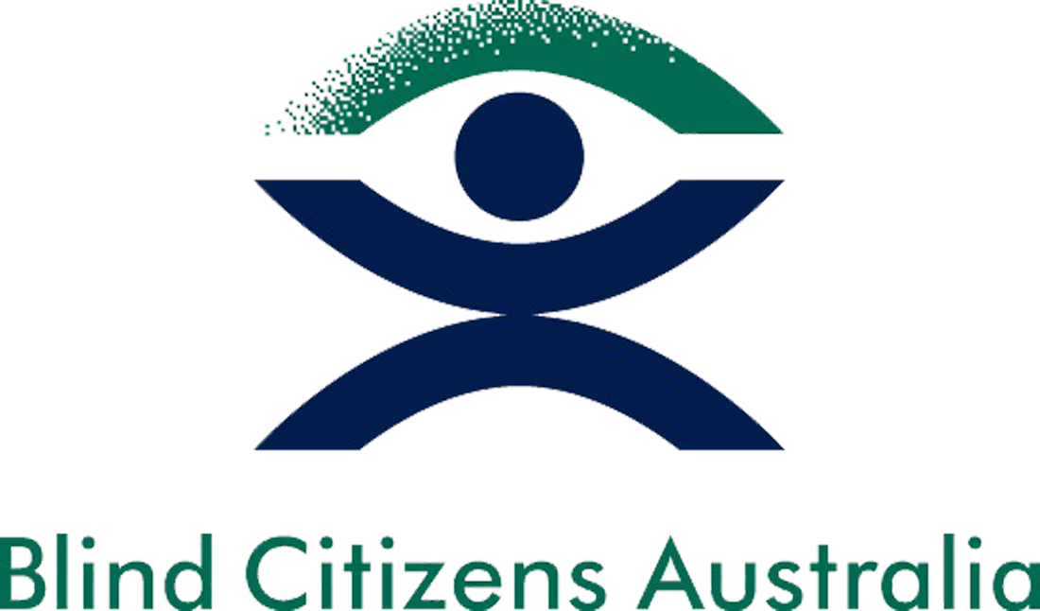

MEDIA RELEASE 18 August 2017

There’s no broadcast reform ‘breakthrough’ without audio description
With Government yet to strike a deal on its broadcast reform, now is the perfect opportunity to make television inclusive and accessible to all Australians by making provisions for audio description.

As it stands, the Broadcasting Legislation Amendment Bill 2017 seeks to pour money into pay-television services rather than prioritise the rights of people who are blind or vision impaired.

Audio description is a second audio track that can be turned on or off, which describes key visual elements of a television program such as facial expressions, scenery, costumes and action.

While audio description has been available on free-to-air-television in all other English-speaking OECD countries for years, Australia continues to lag behind.

Emma Bennison, Executive Officer of Blind Citizens Australia, says: ‘The blindness sector is calling on the Government to ensure that when the Bill is discussed in the next Senate sitting period, beginning 4 September, it includes provisions for permanent audio description services.’

‘Under current legislation, 100 per cent of content broadcast between 6am and midnight is captioned for people who are deaf or hearing impaired, yet more than 453,000 Australians who are blind or vision impaired are left behind.

‘Australia is a signatory to the UN Convention on the Rights of Persons with Disabilities, yet the blind and vision impaired community are excluded from joining in an important aspect of Australian cultural, educational and social life.’

Despite its importance, Australia’s broadcasters consistently argue that audio description is too costly to implement, and while the Government has convened a working group to examine options for audio description services, they are yet to make significant progress in this area.

Ms Bennison says: ‘The Government has been exploring options for audio description on Australian television since 2010. Seven years and two audio description trials later, we are no closer to a permanent audio description service.

‘The Government has taken regulation off the table in its audio description working group, despite the fact that successful audio description services in other countries show us that regulation is the only way forward.

‘Audio description in the broadcast reform should be a priority. Failing this, we urge the Department of Communications to use this working group as an opportunity to make a tangible difference in the lives of Australians who are blind or vision impaired by introducing regulated audio description.’

Carla Northam, CEO of Vision 2020 Australia, says: ‘Vision 2020 Australia joins calls for permanent audio description on free-to-air television.

‘Without audio description it is impossible for people who are blind or vision impaired to fully engage with television content - or participate in conversations about programs with colleagues, classmates or friends.

‘It’s time audio description in Australia caught up with the United Kingdom, the United States, Canada and New Zealand, and the broadcast reform package is an opportunity to do so.’

The Australian Blindness Forum, the Australian Communications Consumer Action Network, the Royal Society for the Blind and Vision Australia also support calls for permanent audio description.

ENDS

For more information:
Lauren Henley at Blind Citizens Australia
03 9654 1400 or lauren.henley@bca.org.au

Ellie Cooper at Vision 2020 Australia
03 9656 2030, 0403 342 922 or ecooper@vision2020australia.org.au

About Blind Citizens Australia
Blind Citizens Australia (BCA) is the united voice of Australians who are blind or vision impaired. Its mission is to achieve equity and equality through empowerment, by promoting positive community attitudes, and by striving for high quality and accessible services which meet the needs of people who are blind. BCA has over 3,000 individual members covering every state and territory in Australia. For more information visit bca.org.au

About Vision 2020 Australia
As the national peak body for the eye health and vision care sector, Vision 2020 Australia represents around 50 member organisations involved in local and global eye care, health promotion, low vision support, vision rehabilitation, eye research; professional assistance and community support. Established in October 2000, Vision 2020 Australia is part of VISION 2020: The Right to Sight, a global initiative of the World Health Organization and the International Agency for the Prevention of Blindness. For more information visit vision2020australia.org.au

