
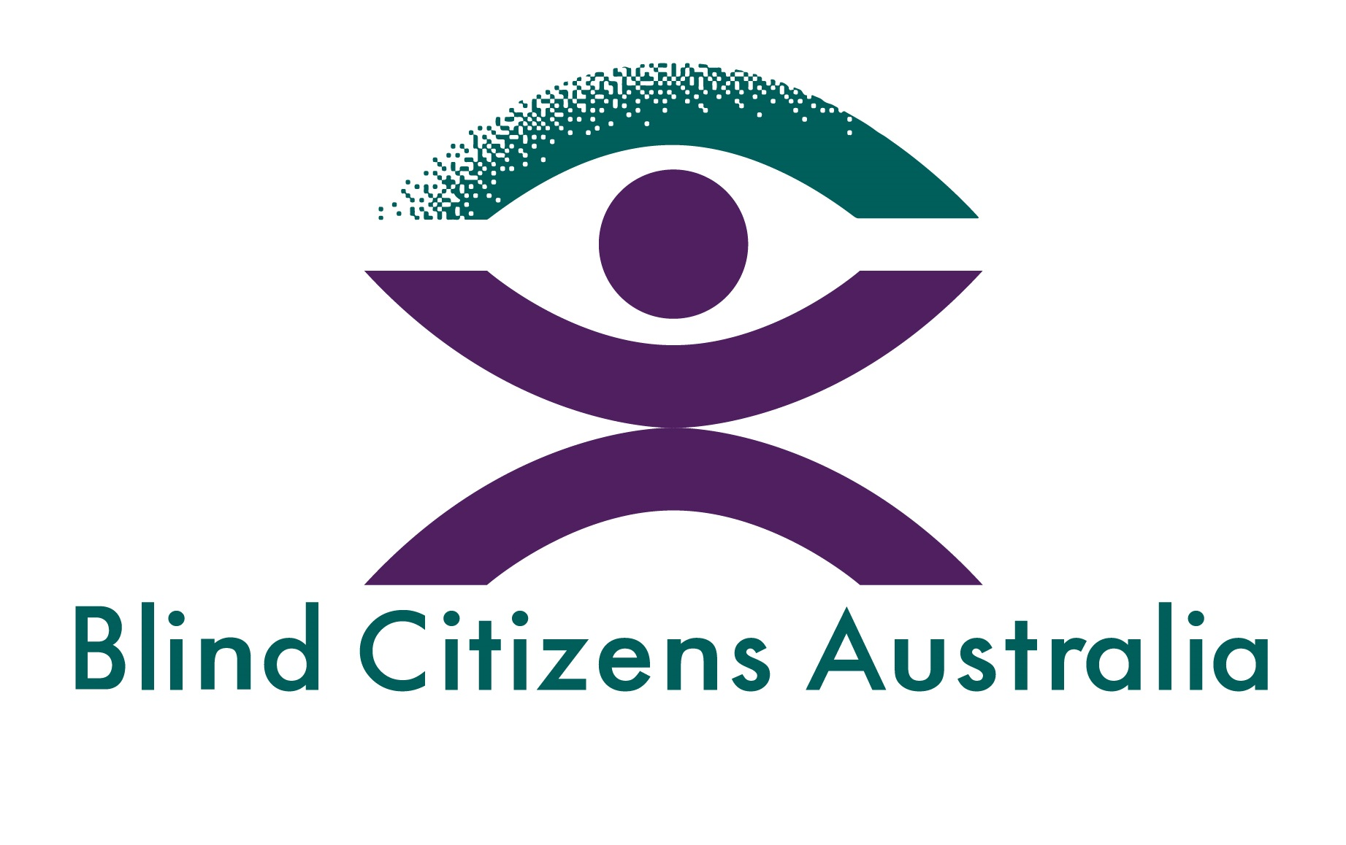

The Importance of Music and Art Supports for People Who Are Blind or Have Low Vision
  - Independent Review of Appropriate NDIS Pricing for Music and Art Supports

  - February 2025

Contents

Introduction 2
Recommendations 2
Benefits of Art and Music Therapy 2
National Braille Music Camp 3
Safeguarding Other Important NDIS Supports 4
References 5
About Blind Citizens Australia 5
About Vision 2020 Australia 6

Introduction
We appreciate Dr Duckett’s invitation to make a submission to his independent review of appropriate National Disability Insurance Scheme (NDIS) pricing for music and art supports.
According to the national Eye Health Survey (2016), there are around 453,000 people with vision loss in Australia. Recent data indicates that vision loss costs Australia up to $27.6 billion annually.
Aside from uncorrected refractive error, which can be mitigated with prescription glasses or contact lenses, most of the vision loss is caused by conditions such as diabetic retinopathy, glaucoma, macular degeneration, and cataract, which usually occur later in life.
Though Australian-based studies are limited, international researchers have found that art and music therapy have therapeutic value for people who are blind or have low vision. This brief submission cites evidence of this, and recommends ways in which other NDIS supports for people who are blind or have low vision can be safeguarded.
For further information about this submission, please contact Vision 2020 Australia (policy@vision2020australia.org.au) or Blind Citizens Australia (bca@bca.org.au).

Recommendations
- In recognition of the measurable positive benefits observed in multiple academic studies, people who are blind or have low vision should continue to have the option of undertaking art and music therapy as part of their NDIS plan.
- Any future decisions about whether a particular profession is or is not evidence-based should be made in close consultation with participants receiving that support type, and with professionals delivering it. That decision should be publicly released and should clearly outline the methods via which the support was tested, and the reasoning for why the support did or did not meet the criteria.

Benefits of Art and Music Therapy
The effectiveness of art and music therapy for people who are blind or have low vision has received a moderate amount of academic attention; more is required, especially from an Australian context.
Whilst art is primarily considered a visual medium, the employment of tactile art materials allows people who are blind or have low vision to participate and reap some therapeutic benefits. For example, a 2017 honours thesis by a student at New York’s Long Island University found that:
“the intervention of art therapy with tactile mediums did relatively have a positive impact on blind clients’ sense of capability. Overall, art therapy with the visually impaired experiencing mental health and behavioral issues was shown to provide moderate improvement in quality of life, therapeutic relief, a sense of self-accomplishment, and a better understanding of themselves through physical materials.”^{[1]}
More has been written about music therapy. In 2023, a scoping study was published by a team of vision, hearing and music therapy researchers from the United Kingdom.^{[2]} The scholars reviewed 13 studies on how music-based interventions are accessed by people with a vision impairment (VI) to promote their psychological, physiological and social well-being. One of those studies had been published by an Australian author in 1991.
The scoping study authors concluded that “music-based intervention strategies improved psychosocial well-being in people with a VI.”^{[3]} Elaborating on their findings, the scholars wrote:
“Several studies suggest that listening to music can induce pleasant and positive feelings by the activation of the limbic system. Music has also been shown to have a broad range of therapeutic effects, such as giving individuals a sense of connection, which fosters a sense of community and promotes feelings of interpersonal attachment which can offset loneliness. Engaging in musical activity leads to a decrease in cortisol which may alleviate anxiety, promote relaxation, improve mood and decrease agitation. Studies have been conducted in VI populations to promote social cohesion, interpersonal communication and for relaxation. Listening to calming music has been used during medical treatment such as cataract surgery. In addition, people with a VI rely on other means of communication such as sound and touch to compensate for their vision loss. Research indicates that people with a VI prefer auditory mediums, such as listening to music or the radio. Children with VI prefer musical toys and enjoy engaging in music as a means of expression.”^{[4]}
Not included in the scoping study was a 2021 study by a team of research psychologists from Iran. These researchers assessed and evaluated the effectiveness of play and music therapy on the anxiety, depression and self-esteem of preadolescent and adolescent school students with a vision impairment. The scholars found that play and music therapy were “cost-effective, simple, familiar, and fun” for the children involved. Moreover, it “was proven that these interventions were effective in reducing anxiety and depression and increasing self-esteem in children” who are vision impaired.^{[5]}
According to Australia’s Stroke Foundation, approximately one-third of stroke survivors experience vision loss. Most people who experience vision loss after a stroke do not fully regain their vision.^{[6]} According to a 2024 study by a team of medical, neurorehabilitation and performing arts scholars from the Netherlands and the United States, music therapy is regularly utilised in stroke rehabilitation. According to these scholars, “Music-based interventions have been used successfully in the treatment of impairments after stroke and have been shown to improve various functions, such as gait, speech/language, impaired arm motor function, and attention.”^{[7]}
Additional Australian-based studies of art and music therapies as experienced by people who are blind or have low vision would be welcome. From the international studies that have been undertaken, it is evident that art and music therapies do have a measurable positive impact on participants’ psychological wellbeing. Music therapy also tangibly improves various physical functions for people who may have experienced stroke-related vision loss.
In recognition of this evidence, art and music therapies should continue to receive adequate NDIS plan funding. This funding should be available for both one-on-one sessions between a participant and an art or music therapist, as well as for group sessions with multiple participants and an art or music therapist. Some participants benefit from the social aspects of group therapy, whereas others learn better without the distraction of classmates. Participants should have the power to choose the option that suits them best.

National Braille Music Camp
Whilst more Australian-based scientific studies would be welcome, there is significant anecdotal evidence as to the benefits of music when performed in group settings.
Music camps allow participants to develop skills, engage in recreational activities and socialise amongst their peers. One such example is the National Braille Music Camp, which gathers students from across the country to develop their reading and writing skills, often instructed by people with lived experience.
As well as teaching a valuable skill, these camps often build connections which are then maintained digitally. It is not uncommon for participants to create lifelong friendships at the National Braille Music Camp, a testament to the transformative power of such events.
Given the comparatively low prevalence of vision impairment, and the geographic dispersal of Australia’s population, many attendees report that they met another person with a vision impairment for the first time at a music camp. With more students who are blind or have low vision attending mainstream schools, it is important that there remain opportunities for connection with peers who have the same disability.
A music camp setting also provides somewhat of a therapeutic aspect in and of itself, in that unlike most areas of life where the onus is on an individual who is blind or has low vision to communicate the adjustments they need to participate, these adjustments are understood and provided as a given, allowing the person to participate and be fully included without a sense of anxiety about limitation. Participants have thus described music camps as a “safe space”.
Connections with peers encourage people to aspire towards independence, and have a positive impact on mental health. Music camps are peer led, with participants taught by someone from the blind or low vision community. This creates empowering leadership and mentoring opportunities for people who are blind or have low vision, and demonstrates that subject mastery is possible with hard work and commitment.
In recent years, the increasingly heavy regulatory burden and growing insurance costs have resulted in fewer camps being held in Australia. When they do occur, camps are typically underwritten by philanthropy, which is increasingly unable to cover the cost of delivering these activities.
The NDIS model of support delivery has proven administratively complex as a funding source for camp activities, since it is designed to facilitate services delivered to individuals or small groups. As such, we have previously called for camps like the National Braille Music Camp to receive funding as a foundational support.

Safeguarding Other Important NDIS Supports
In changes set to come into effect from February 1 this year, art and music therapies will be removed from the NDIS’s Capacity Building – Improved Daily Living category. Unless a participant can prove that the therapies improve or maintain their “functional capacity”, they will only be able to bill the Scheme at a “community rate” of $68 per hour, down from the therapy support rate of $194 per hour.
We are concerned by this decision. Firstly, it will have a direct impact on people who are blind or have low vision who benefit from art and music therapies. Secondly, the decision was made without justification nor, according to media reports, consultation with the art and music therapy communities.
Most vision services are not officially recognised by the National Disability Insurance Agency. We can foresee a time when for providers (such as orientation and mobility specialists) to continue charging the therapy support rate, they will have to prove the therapeutic benefits of what they deliver.
We strongly contend that any decisions about whether a particular profession is or is not evidence-based should be made in close consultation with participants receiving that support type, and with professionals delivering it. Further, that decision should be publicly released and should clearly outline the methods via which the support was tested, and the reasoning for why the support did or did not meet the criteria.

References
1. DiGiulio, Deanna. “The Use of Art Therapy with the Blind to Impact a Sense of Capability.” Honours Thesis, Long Island University, 2017, p. 2. https://digitalcommons.liu.edu/cgi/viewcontent.cgi?article=1023&context=post_honors_theses
2. Somani, Nurbanu, Eldre Beukes, Alexander Street, et al. “Effectiveness of Music-based Interventions to Address Well-being in People with a Vision Impairment: A Scoping Review.”
BMJ Open 13 (2023): 1-17, doi:10.1136/bmjopen-2022-067502
3. Ibid., p. 1.
4. Ibid., p. 2.
5. Taheri Shohreh, Seyyedeh, Mansoure Shahriari Ahmadi and Hasanpasha Sharifi. “Effectiveness of Play and Music on Anxiety, Depression, and Self-esteem in Secondary School Students with Visual Impairment.” Scientific Journal of Rehabilitation Medicine 10, no. 5 (2021): 976-987, at 977, doi:3SJRM/10.32598/org.
6. Stroke Foundation – Australia. “Vision Loss After Stroke.” Accessed January 23, 2025. https://strokefoundation.org.au/what-we-do/for-survivors-and-carers/after-stroke-factsheets/vision-loss-after-stroke-fact-sheet
7. Dimitriadis, Theo, Mohammed A. Mundarris, Dieuwke S. Veldhuijzen, et al. “Music Therapy with Adults in the Subacute Phase After Stroke: A Study Protocol.” Contemporary Clinical Trials Communications 41 (2024): 1-8, at 1, doi:10.1016/j.conctc.2024.101340

About Blind Citizens Australia
Blind Citizens Australia (BCA) is the peak national representative organisation of and for the over 500,000 people in Australia who are blind or vision impaired. For nearly 50 years, BCA has built a strong reputation for empowering Australians who are blind or vision impaired to lead full and active lives and to make meaningful contributions to our communities.
BCA provides peer support and individual advocacy to people who are blind or vision impaired across Australia. Through our campaign work, we address systemic barriers by promoting the full and equal participation in society of people who are blind or vision impaired. Through our policy work, we provide advice to community and governments on issues of importance to people who are blind or vision impaired. As a disability-led organisation, our work is directly informed by lived experience. All directors are full members of BCA and the majority of our volunteers and staff are blind or vision impaired. They are of diverse backgrounds and identities.

About Vision 2020 Australia
Vision 2020 Australia is the national peak body for the eye health and vision care sector. Working with and representing almost 50 member organisations, we focus on supporting policy and funding changes to prevent avoidable blindness, enhance eye care delivery and better meet the needs of people who are blind or living with low vision.
Vision 2020 Australia is the national peak body for the eye health and vision care sector. Working with and representing almost 50 member organisations, we focus on supporting policy and funding changes to prevent avoidable blindness, enhance eye care delivery and better meet the needs of people who are blind or living with low vision.
Our members span a wide range of areas and engage in local and global eye health and vision care, health promotion, low vision support, vision rehabilitation, eye research, professional assistance, and community support. This means that the work we do in developing sector-supported policy and advice brings a diverse range of expertise and perspectives to bear, and that the perspectives and experiences of both service users and service providers are at the heart of our work.
Avoidable blindness and vision loss in Australia, and our region, can be prevented and treated by working in partnership across government, non-government, private and community sectors. People of all ages who are blind or vision impaired will benefit from these partnerships, with improved access to services that support their independence and community participation.

